NAME: ……………………………………………………. PERSONAL NO. ………

840/1
COMPUTER STUDIES
(PRACTICAL)
Paper 1
JUL/AUG.2019
2 hours 30 Minutes


MUKONO EXAMINATION COUNCIL
UGANDA CERTIFICATE OF EDUCATION
COMPUTER STUDIES
Paper 1
2 Hours 30 Minutes

INSTRUCTIONS TO CANDIDATES
- Attempt all questions.
- Write your name and stream in the spaces provided.
- This paper consists of three sections: A, B and C.
- Write your best alternative: A, B, C or D, in the boxes opposite questions 1 to 20.
- Answers to Section B should be written in the spaces provided.
- Section C contains three essay questions. Answer only one. Answers to section C must be written in the answer booklets provided.
For Examiner’s Use Only
MCQ | Q21 | Q22 | Q23 | Q24 | Q25 | Q26 | Q27 | Q28 | Q29 | TOTAL

SECTION A (20MARKS)
- What feature in word processing automatically takes a word to the next line when
typing?

- Word wrap
- Wrap ring
- Wrap round
- Wrap siding

- Which of these storage devices is a sequentially accessed media?

- Hard disk
- Floppy disk
- Magnetic tapes
- Memory sticks.

- Which of the following system software that uses command line interface
A. DOS B. Windows XP

C. Microsoft word D. Voltmeter

4. Which of the following keyboard shortcuts converts a selection to a subscript?

- Ctrl + V
- Ctrl + E
- Ctrl + Shift + plus

- Ctrl + = (equal sign)

5…………… is the formula that does not change when copied to another location in

spreadsheet

- Absolute reference
- Primary key
- Function
- Relative reference

6. Which of the following is an example of an audio file?

- MPG
- AVI
- MPV
- MID

7. ……prevents a problem on the computer called ghosting.

- Icons
- Screen saver
- Software
- hardware

8. Which of the devices is used to keep data, instructions and information for future use?

- Storage medium
- Storage capacity
- Storage device
- Primary storage

9. Which of the following programs tells the device on how to communicate with the computer?

- Ms word
- Application software
- Device drivers
- Ms power point.

10. To connect a computer to a network, a user’s machine should have a (an)……..

- NIC
- RJ45
- IP

- ISP.

11. An email travels in small envelopes called……….

- Switches
- Packets
- Strings
- letters and headers.

12. Which one of the following changes the high level language to machine code?

- Compiler
- interpreter
- Linker

- Assembler.

13. What is information technology?
- It is the central processing system unit and monitor

- It is the tangible components of a computer.
- It is all types of equipments and programs used in processing
- It is a combination of software and programs.

14. …………is the conversion of digital signals to analog signals.

- Modulation
- Packet switching
- Demodulation
- Communication.

15. …………… a device that connects two LANS using the same protocol.

- Repeater
- Router
- Bridge

- Switch.

16. In spreadsheets, the formula that does not change when copied to another location is known as….

- Absolute reference
- Primary key
- Function
- Relative reference

17. Which of the following internet services offers real time communication?

  - Chat room
  - Instant messaging
  - Group ware
  - E-mail.

18. What term describes the incorporating comfort, efficiency and safety into the design of items in the work place like in a laboratory?

  - Ergonomics
  - Proper sitting
  - Supervision
  - Proper mouse usage

19. Which type of a printer is fast and produces quality print out?

  - dot matrix

  - desk jet
  - bubble printer
  - Laser printer.

20. What computer generation led to the introduction the machine and assembler language?

- First generation C. Second generation
- Third generation D. Fourth generation

SECTION B. (60 MARKS)

21a) Give the use of the following scanning input hardware devices.
- Optical Mark Recognition Reader (OMR) (2 marks)

…………………………………………………………………………………........................................................................................................................................................................................
- Optical Character Recognition Reader (OCR). (2 marks)
………………………………………………………………………………………………………………………………………………………………………………………………........................
b) Mention three reasons why biometric systems are used as opposed to other methods of data capture. (3 marks)
………………………………………………………………………………………………………………………………………………………………………………………………………………………………………………………………………………………………....................................
- List one example of biometric devices. (1 mark)
………………………………………………………………………………….............
c) Give two areas where the technology of biometric devices has been applied.
(2 marks)
………………………………………………………………………………………………………………………………………………………………………………………………........................

22.ai) Distinguish between task bar and a menu bar. (2 marks)
………………………………………………………………………………………………………………………………………………………………………………………………........................
- What is the use of a recycle bin on a computer? (1 mark)
……………………………………………………………………………………………………………………………………………………………………...............................................................

b. i) Suggest any two reasons why a file should be compressed. (2 marks)
………………………………………………………………………………………………………………………………………………………………………………………………........................
ii) State three symbols that should not be included when naming a file (3 marks)
………………………………………………………………………………………………………………………………………………………………………………………………………………………………………………………………………………………………....................................
c) Mention any two advantages of keeping your work in a folder on the desktop.
(2 marks)
……………………………………………………………………………………………………………………………………………………………………………………………….......................

23a) Briefly explain the following terms as used in data communication.
- Communication devices. (2 marks)
……………………………………………………………………………………………………………………………………………………………………........................
- Data communication media. (2 marks)
…………………………………………………………………………………………………………………………………………………………………….......................
b) Identify and name the cables used in data communication below. (2 marks)
Cable A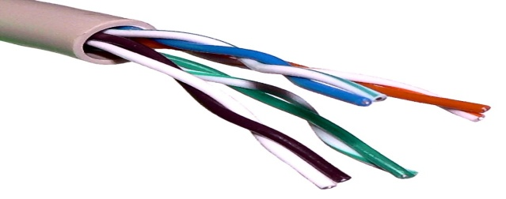

Cable A: ………………………………………………………………………………................…

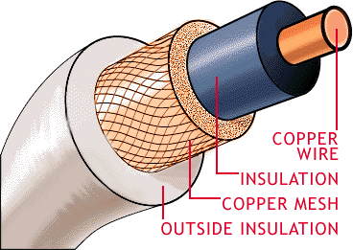

Cabble B

Cable B: ……………………………………………………………………………………............

C) i) Give two advantages of using cable A. (2 marks)

........................................................................................................................................................................................................................................................................................................................

ii) Mention one application of cable A and cable B. (2 marks)

Cable A: ………………………………………………………......................................................

Cable B: ………………………………………………………........................................................

24. Below is the window layout of an Internet Explorer browser, answer the questions given.

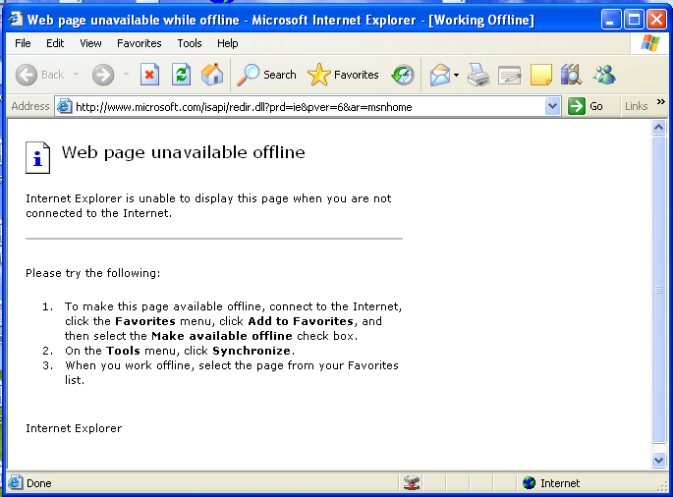

A
B

a. i) Name the buttons named A and B on the window. (2 marks)
A: …………………………………………………………..................................................
B: …………………………………………………………. ................................................

ii). Give the use of button A and B as labeled on the window above. (2 marks)
A: ………………………………………………………………………………………………………………………………………………………………………………………….......
B: ……………………………………………………………………………………………………………………………………………………………………………...........................
b.i) Distinguish between a browser and a search engine. (2 marks)
…………………………………………………………………………………………………………………………………………………………………………………………………………........
ii) List any two examples of a search engine. (2 marks)
…………………………………………………………………………………………………………………………………………………………………………………………………………........
c) Internet has been in existence for some good years however some people have failed to embrace it despite the development in technology. Give two reasons why people have failed to embrace internet. (2 marks)
…………………………………………………………………………………………………………………………………………………………………………………………………………........

25. Briefly explain the responsibilities of the following professionals in the ICT sector.
i) System analyst: (2 marks)
…………………………………………………………………………………………………………………………………………………………………………………………………………........
ii) Database administrator: (2 marks)
…………………………………………………………………………………………………………………………………………………………………………………………………………........
b) The increase in the use of technology has highly led to an increase the use of the expert system.
i) What is meant by an expert system? (2 marks)
…………………………………………………………………………………………………………………………………………………………………………………………………………........
ii) Mention one area where the expert system has been applied. (1 marks)
………………………………………………………………………………………………………………………………………………………………………………………………………….......
iii) Give three disadvantages of using the expert system. (3 marks)
………………………………………………………………………………………………………………………………………………………………………………………………………………………………………………………………………………………………………………...........

26. a) Distinguish between the following
i) algorithm and syntax. (2 marks)
…………………………………………………………………………………………………………………………………………………………………………………………………………........
ii) Flow chart and program (2 marks)
…………………………………………………………………………………………………………………………………………………………………………………………………………........
b) Briefly explain three factors to consider when choosing a programming language.
(3 marks)

………………………………………………………………………………………………………………………………………………………………………………………………………….......
……………………………………………………………………………………………………...
c) Writing a computer program involves a series of steps/stages. Outline the first three.
(3 marks)
…………………………………………………………………………………………………………………………………………………………………………………………………………
……………………………………………………………………………………………………
……………………………………………………………………………………………………

SECTION C (20 MARKS)
Attempt only ONE question in this section. Answers to the question must be done in
the answer sheet provided.
27. a) Distinguish between a data base and a database management system. (4 marks)
b) The data type of a field specifies the type of data that the field can contain. Explain the
different data types that are used while designing tables in data base. (10 marks)
c) Mention the different advantages of using electronic database over manual data base
(6 marks)
28 (a) Explain the meaning of the following computer devices. (10 marks)
- Printer.
- Microphone
- Touch pad
- CCTV (Closed Circuit Television) Camera
- Modem
(b) Describe the procedure in printing an Office Word document. (10 marks)

29. a) What is the main use of the uninterruptible power supply? (2 marks)
b) Power disruption is one of the threats users find in the computer laboratory. Explain the
causes of power disruption. (10 marks)
c) Describe the examples of computer specifications considered before buying a computer. (8 marks)

END

